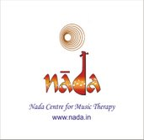NADA CENTRE FOR MUSIC THERAPY, CHENNAI (REGD)

Creating Landmarks in Lectures, Demos, Interviews, Workshops ,Conferences…

Here, There and Everywhere!
Event | Title |  | Collaborators with Nada Centre for Music Therapy |  |  |  | DATE/ Venue
2001 | 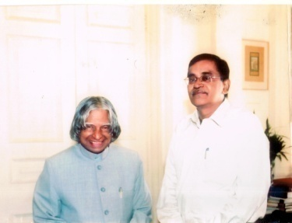 |  | 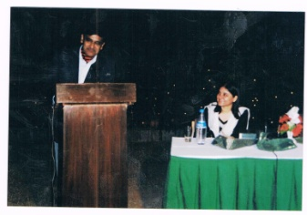 |  |  |  | 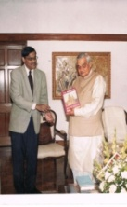
0001 | LECTURE- Music therapy- problems and prospects by TV Sairam |  | India Habitat Centre, |  |  |  | Mar, 2001 - Gulmohar Hall, IHC, New Delhi
0002 | WORKSHOP - The Yoga of Music |  | Delhi Music Society & Max Mueller Bhawan |  |  |  | Sep, 14 2001 - Max Mueller Bhawan, 3, KG Marg, New Delhi
0003 | LECTURE - Meditative music by TV Sairam |  | Mantram Art Foundation & India Habitat Centre, |  |  |  | 2001 - India Habitat Center, New Delhi
0004 | LECTURE - Indian music therapy - by TV Sairam with Padma Subramaniam on veena |  | India International Center (IIC), |  |  |  | 2001 - India International Center (IIC), New Delhi
2002 | 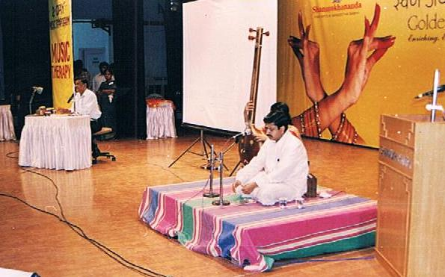 |  | 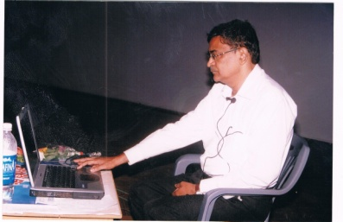 |  |  |  | 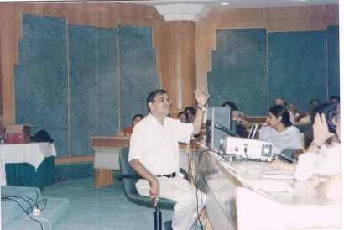
0005 | NATIONAL SYMPOSIUM - Music Therapy FOR ALL By TV Sairam |  | Sri Shanmukhananda Fine Arts & Sangeetha Sabha, Mumbai. |  |  |  | Sep 14 & 15, 2002. ( Sri Shanmukhananda Fine Arts & Sangeetha Sabha, Mumbai)
0006 | NATIONAL SYMPOSIUM on Music Therapy- indian music therapy - Key Note by TV Sairam |  | Gerontological Society of India , New Delhi |  |  |  | Sep 2002 (IIC, New Delhi)
2003 | 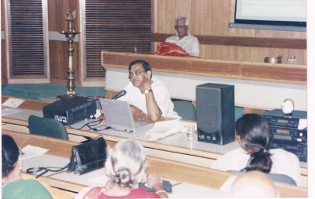 |  | 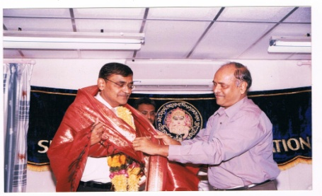 |  |  |  | 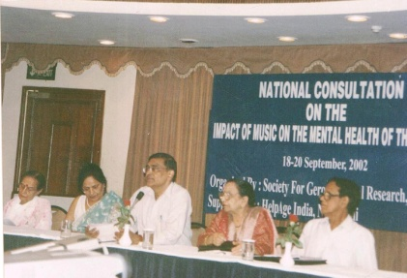
0007 | LECTURE -Applied music - by TV Sairam |  | National Eminence Award Function, Visakhapatnam |  |  |  | Kala Bharati Auditorium, Visakhapatnam- Aug 11, 2003
0008 | LECTURE - Music: an interpretation – by Dr Sairam |  | Centre for Policy Studies, Visakhapatnam |  |  |  | Public Library, Visakhapatnam - Apr 30, 2003
0009 | LECTURE - Music and mind : An Interactive Presentation by TV Sairam |  | India International Centre (IIC), New Delhi |  |  |  | India International Centre (IIC), New Delhi - Jan 3, 2003
2004 | 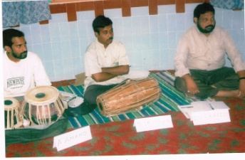 |  | 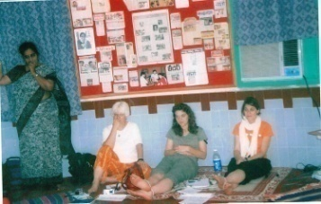 |  | 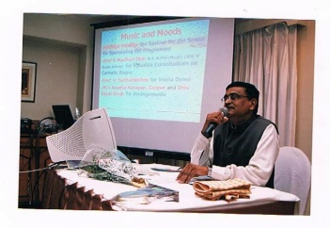
0010 | SURVEY- The relevance of music therapy in india - An on –the- spot-survey conducted by TV Sairam (“Vizag Survey”) |  | Centre for Policy Studies, Visakhapatnam |  | Builders’ Auditorium, Visakhapatnam- Apr 25, 2004
0011 | LECTURE Music and emotion - A Radio Broadcast by TV Sairam |  | Prasar Bharati, All India Radio, Visakhapatnam |  | All India Radio, Visakhapatnam -Jan 31, 2004
0012 | LECTURE Music and consciousness - A Radio Broadcast by TV Sairam |  | Prasar Bharati, All India Radio, Visakhapatnam |  | All India Radio, Visakhapatnam -May 8, 2004.
0013 | LECTURE Rhythms- A Radio Broadcast by TV Sairam |  | Prasar Bharati, All India Radio, Visakhapatnam |  | All India Radio, Visakhapatnam -May 22, 2004.
0014 | LECTURE Music and mood – by TV Sairam with V Subbulakshmi on Veena |  | Vintage Visakha, Visakhaptanam |  | Green Park, Visakhapatnam -Apr, 20, 2004 (?)
0015 | INTERVIEW Healing with music - An Interview of TV Sairam by A.R.S |  | The Hindu |  | April 30, 2014
0016 | INTERVIEW Of musical yearnings – An Interview of TV Sairam by Aparna Ramalingam |  | Financial Express |  | Aug 7, 2004
0017 | INTERVIEW Music can help you lower stress levels - An interview of TV Sairam by Aditi Sharma |  | Asian Age |  | Mar 1, 2004
2005 | 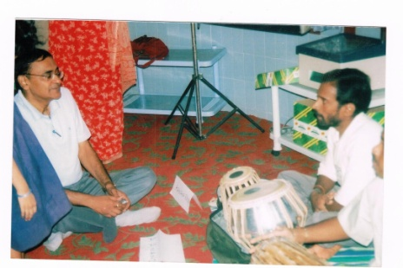 |  | 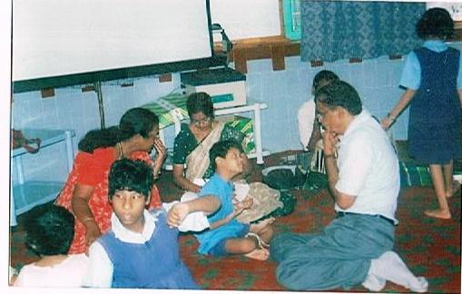 |  | 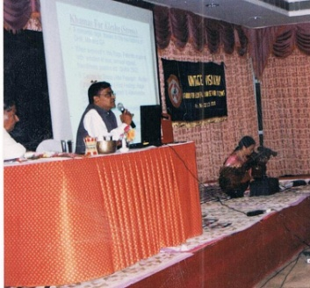
0018 | The yoga and music - Lec-Dem by TV Sairam |  | Sri Rajalakshmi Foundation Endowment Lecture- 2005. |  | Public Library, Dwarakanagar, Visakhapatnam - Mar 23, 2005
0019 | Raga therapy by TV Sairam- A Book Review |  | Ayurveda and All, New Delhi |  | Apr 2005: 56
0020 | INTERVIEW Help them become self-reliant! – An Interview of TV Sairam |  | The New Indian Express
0021 | INTERVIEW Raga therapy soothes disturbed minds ! – An interview of TV Sairam by Vasudevan Patri |  | The Hindustan Times |  | 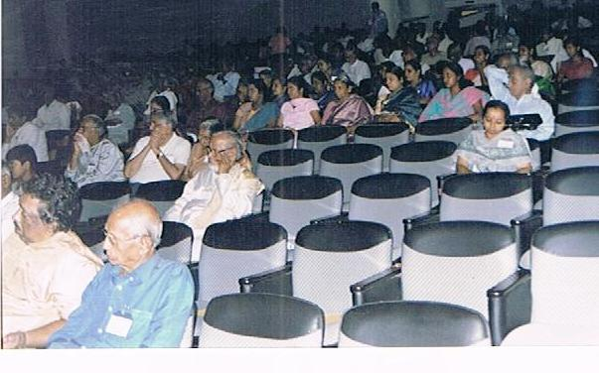
 | 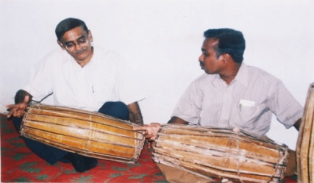 |  | 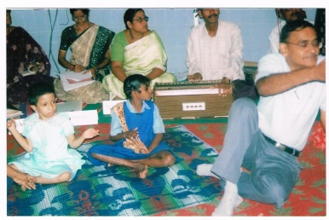 |  | 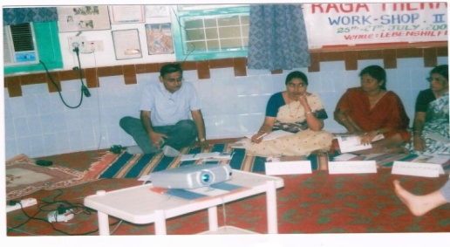
0022 | Raga therapy for the mentally-challenged – A Presentation by TV Sairam |  | Lebenshilfe, Visakhapatnam. |  | April 9, 2005
2006 |  | 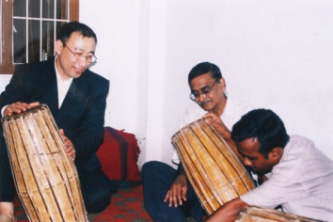 |  | 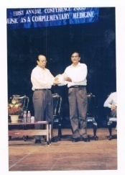 | 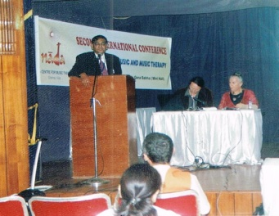
0023 |  | First International Conference on Therapeutic Usefulness of Music - Inaugural address on Music Therapy for Tsunami Survivors of Tamil Nadu - by Dr TV Sairam) |  | Key Note: Ryo Takashi, Japan; Chief Guest: Dr PL Sanjeeva Reddy IAS, Director IIPA & MVS Prasad, Chief Commissioner (C&E) | Jan 15, 2006. (Naradha Gana Sabha (Mini Hall), 314, TTK Road, Chennai
0024 |  | BOOK RELEASE - Music Therapy: The Sacred & the Profane. Edited by TV Sairam |  | First International Conference on Therapeutic Usefulness of Music | Jan 15, 2006. (Naradha Gana Sabha (Mini Hall), 314, TTK Road, Chennai
0025 |  | INTERVIEW Can an integration of different musical cultures be useful for music therapy? - An interview of TV Sairam by Maria Ivannikova. |  | Voices: Moderated Discussion | 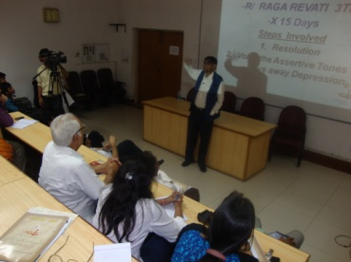
0026 |  | LECTURE -Medicinal Music- A Lecture demonstration on Indian Music Therapy by TV Sairam |  | Visakhapatnam Music Academy (VMA) Annual Conference | Nov 26, 2006. (Kalabharati Auditorium, Visakhapatnam)
0027 |  | INTERVIEW Music mantra -An interview of TV Sairam by Mercilin S Madathil |  | Vacancies for You, Mumbai | Sep 6, 2006
2007 |  | 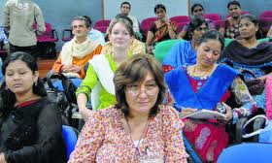 | 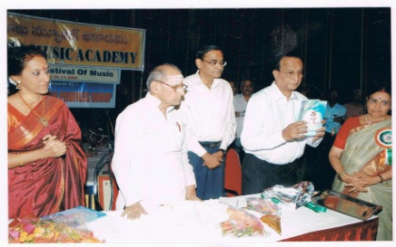 |  |  | 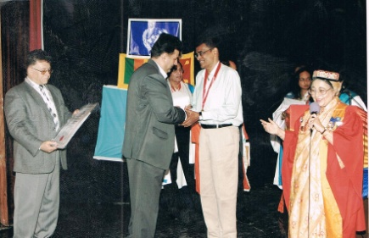
0028 |  | BOOK RELEASE- Self- Music Therapy: Musings on Music Therapy by TV Sairam | Vizag Music Academy, Annual Music Festival -2007- Book Release by Sri Nedunuri Krishnamoorthy & Bombay Jaishree |  |  | Nov, 2007 (Kalabharathi Auditorium, Visakhapatnam)
0029 |  | KEY NOTE ADDRESS- UGC-Sponsored National Seminar on Music Therapy & Mental Health - by TV Sairam | RRMK Arya Mahavidyalaya, Pathankot (Punjab) |  |  | Jan 20& 21, 2007. ( RRMK Arya Mahavidyalaya, Pathankot)
0030 |  | INVITED LECTURE- The Yoga of Music: Therapeutic Aspects of Nada Yoga by TV Sairam | International Indological Conference, Goa |  |  | Feb, 10, 2007 (Goa)
0031 |  | KEY NOTE SPEECH - National Conference on Music Therapy as an Alernative Medicine, –by TV Sairam | Nada Centre for Music Therapy, Chennai & Society of Gerontological Research, New Delhi) |  |  | India International Centre, Annexe, New Delhi - Feb 12-13, 2007.
2008
0032 | INTERVIEW Music Therapy (A National Programme of AIR - Interview of TV Sairam) | All India Radio, Parliament Street, New Delhi |  | Feb 2008 (Delhi AIR)
0033 | Music Therapy by TV Sairam | Nada Centre for Music Therapy & India International Centre, New Delhi | Apr 16, 2008. (IIC Seminar Hall, Lodhi Estate, New Delhi)
0034 | Impact of Music on Alzhiemer’s Disease – TV Sairam | NISD, Min. of Social Justice and Empowerment , New Delhi | Apr 20, 2008 (NISD, New Delhi)
0035 | An Introduction to Music Therapy (Key Note Address by TV Sairam) | National Seminar on Music Therapy by Nada Centre for Music Therapy & Vagdevi Vignana Kendram | July 6 & 7, 2008 (Bharatiya Vidya Bhawan Auditorium, Hyderabad)
0036 | Trends in Music Therapy by TV Sairam (in absentia) | Kriti Kala Sansthan ,Agra | Aug 13, 2018 (Kriti Kala Sansthan, Delhi Public School, Agra
0037 | 2nd International Conference on Psychology of Music and Music Therapy – Key Note by TV Sairam | Nada Centre for Music Therapy, Chennai(Chair persons: Gowri Rammohn, Psychology & Music Prof Vizag, Dr TI Radhakrishnan Neuro-surgeon, Thrissur Prof SAK Durga,, Madras University) | Nov 15, 2008 (Naradha Gana Sabha (Mini Hall) 324 TTK Road, Chennai)
0038 | AMTA (American Music therapy Association) Demo on Therapeutic Ragas of India - by TV Sairam | American Music Therapy Association Conference at St Louis (USA) | Nov 21, 2008 (St Louis, USA)
0039 | Silver Jubilee World Congress. Presentation on Music Therapy by TV Sairam | Nada Centre for Music Therapy, Chennai & Medicina Alternativa. Open International University for Complementary Medicine | Jan 19-20, 2008 (Russian Cultural Centre, Mumbai)

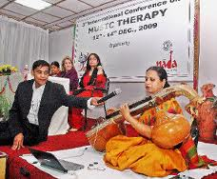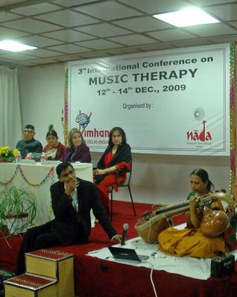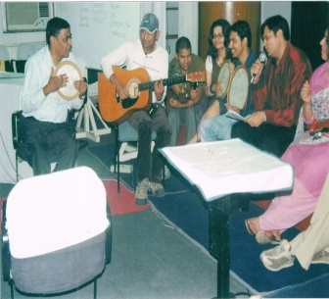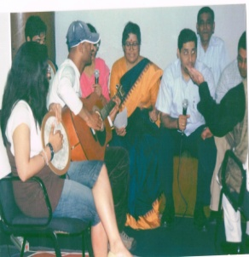
2009
0040 | LECTURE- Music Therapy and the Elderly WITH Music Demo by TV Sairam | Andhra University Gerontology International Synthesis | Jan 2009. Andhra University, Visakhapatnam (Conference inaugurated by Former President Mr Abdul Kalaam)
0041 | Medicina Alternativa World Congress)- Therapeutic Music Demo by TV Sairam | Zoroastrian College, Mumbai (Medicna Alternativa World Congress) | Jan 26, 2009 (Russian Cultural Centre, Peddar Road, Mumbai)
0042 | 3-Day Music Therapy Workshop for Professional Psychologists and Psychiatrists – Key Note by TV Sairam | Nada Centre for Music Therapy & VIMHANS, New Delhi | Mar 6-8, 2009 (Vimhans Hospital, New Delhi )
0043 | Raga Therapy: The Miracle of Microtones by TV Sairam (with Veena support by Padma Subramaniam) |  | May 19, 2009 (IIC Annexe, Lodhi Road, New Delhi)
0044 | Music Therapy: Concepts & Practices by TV Sairam |  | May 23, 2009 (GulMohar Hall, India Habitat Centre, Lodhi Road, New Delhi)
0045 | AMTA American Music Therapy Association Conference- 2009. Presentation by TV Sairam on Raga Therapy for Non-Indian Music Therapists | American Music Therapy Association (AMTA) Conference at St Louis (USA) | November 12, 2009 (San Diego, USA )
0046 | Raga Chikitsa for an International Audience by TV Sairam |  | Nov 21, 2009 (Sri Balaji Temple, Birmingham U.K.)
0047 | Raga Therapy: The Miracle of Microtones- A Lec-Dem | Visakha Music Academy, 40th Annual Festival of Music and Dance | Nov 29, 2009 ( Kala Bharati Auditorium, Visakhapatnam)
0048 | 3rd International Conference on Music and Music Therapy. | VIMHANS, New Delhi | Dec 5-7, 2009 (Vimhans Hospital Auditorium, Nehru Nagar, New Delhi)
0049 | Ragas in Emotional Healing ( Lec Demo in Tamil) by TV Sairam |  | Dec 26, 2009 (Ranjani Hall, 15th Street, Nanganallur, Chennai)
0050 | INTERVIEW Music Heals- An interview of Dr Sairam by Deepika Saravanan | Nanganallur Times, Chennai | Oct 11-17, 2009
0051 | INTERVIEW Wired to Melody- A Review of Dr Sairam’s Presentation in IIC, New Delhi | The Hindu | Jun 5, 2009.
2010
0052 | 4th International Conference on Psychology of Music and Music Therapy | Dept of Psychology and Parapsychology, Andhra University, Visakhapatnam | Dec 4&5, 2010 (Platinum Jubilee Guest House, Andhra University, Visakhapatnam)
0053 | Raga Therapy Ingredients by TV Sairam | Lebenshlfe, Visakhapatnam | Dec 6, 2010 ( Lebenshilfe, Visakhapatnam)
0054 | Healing Music in Ancient Traditions: AN INTERNATIONAL Symposium |  | Dec 7, 2010 (Dept of Psychology, Andhra University, Visakhapatnam)
0055 | Raga Therapy as a MEntal Intervention |  | Apr 8, 2010 (Behala Bodhayan- A Centre for Special Children, Kolkata)
0056 | Ancient Musical Forms and their Therapeutic Relevance – by TV Sairam | International Ancient Arts Festival, New Delhi | April 11, 2010 (Azad Bhawan, IP Estate, New Delhi)
0057 | Music for Seniors and Senior Music – by TV Sairam |  | April 23, 2010 (Gul Mohar Hall, IHC, Lodhi Road, New Delhi)
0058 | Music Therapy- A Lec Dem | Rotary Club of Delhi Mid-Town | May 21, 2010. (Venue: The Imperial, New Delhi)
0059 | Music Therapy for Medical and Para-medical Employees of Global Hospital, Chennai by TV Sairam | Global Hospital, Chennai | May 28, 2010 (Global Hospital, Chennai)
0060 | American Music Therapy Association National Conference, Cleveland, Ohio, USA - Making Raga Research Relevant in Music Therapy Practices and Advocacy –by TV Sairam | American Music Therapy Association (Approved by Certification Board of Music Therapists (CBMT) for 6 Continuing Music Therapy Education Credits) | Nov 21, 2010. ( Cleveland, Ohio, USA)
0062 | Interview on Resonance (For a documentary filmed by Natasha and Fabien, the French Music Therapists) |  | Nov 24, 2010 (Paris, France)
0063 | Meeting with Monsieur Baschet, the Acoustic Engineer at his residence near Paris (France) |  | Nov 24, 2010 (Paris, France
0064 | Medicinal Music - An Interactive Lecture Demonstration. | Music Forum, Chennai | May 30, 2010. (Bharatiya Vidya Bhawan Auditorium, Mylapore, Chennai)
0065 | Music for Seniors- a Demo by TV Sairam |  | Aug 27, 2010. (Dignity Foundation, Chennai)
0066 | Raga Therapy by TV Sairam |  | Aug 28, 2010 (Life Academy, Chennai)
0067 | Introducing Music Therapy for Doctors and Psychologists – by TV Sairam |  | Sep 10, 2010 (Vimhans Hospital, New Delhi)
0068 | INTERVIEW Executives turn to Music Therapy to de-stress! An interview of TV Sairam | Economic Times | Oct 11, 2010
0069 | Music Therapy (A Workshop for the Parents and Caretakers of Special Children) –by TV Sairam | Asha Centre for Developmental Disabilities, Benagluru | Oct 23, 2010 (Army Welfare Association, Bangalore)
0070 | Nature in Music and Music in Nature – Therapeutic use of Nature’s Sounds by TV Sairam | Art History Congress | Oct 30, 2010 (Vivekananda Kendra, Kanyakumari, Tamil Nadu)
0071 | INTERVIEW Contribution of the Indian Music Therapists – an interview of Dr Sairam by Dr Ram Manohar Sharma | IRRC | Sep 2010
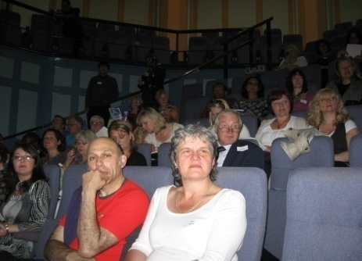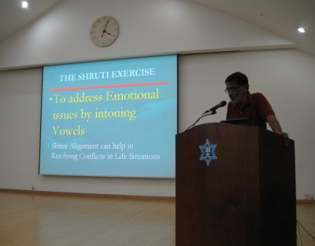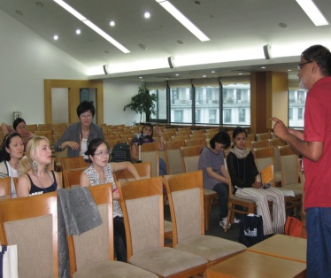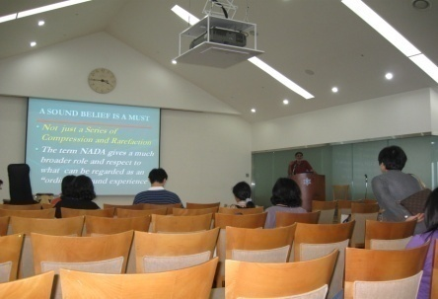
2011
0072 | Raga Therapy (Book) Release of 2nd Edition |  | Second Edition , 2011.
0073 | Music Therapy by TV Sairam  IN THE presence of Swami Dayananda Saraswati |  | Mar 20, 2011 (Swami Dayananda Ashram, Rishikesh)
0074 | Two-day workshop on Music Therapy conducted by TV Sairam |  | Apr 15-16, 2011 (Vimhans Hospital, New Delhi)
0075 | 5th CCTN Conference on Complementary Therapies. ‘Proto-raga therapy for Special Children’ – By TV Sairam | Freshwinds (Children’s Complementary Therapy Network, | May 7, 2011. (. Children’s Hospital, Birmingham (UK)
0076 | Nada Yoga in the Himalayas! |  | May 28-31, 2011. (Srinagar, Uttarakhand)
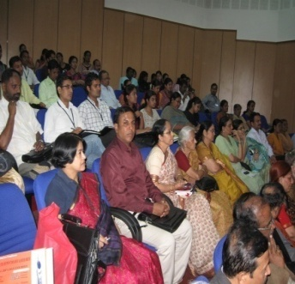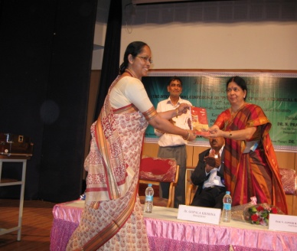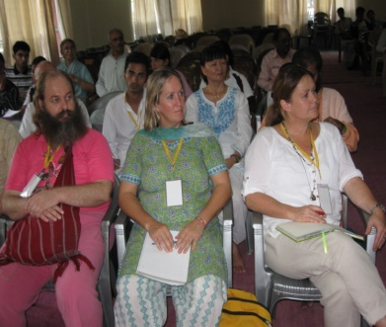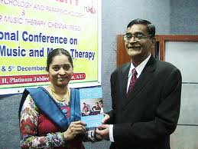
2012
0077 | Therapeutic Application of Music Therapy across Cultures | The David Ott Pre-conference Institute (AMTA) | Mar, 31,2012.(Room Chesapeak 3-4) (American Music Therapy Association’s Pre-conference Workshop)
0078 | Workshop on Music Therapy Nada Yoga | HH Sri Sri Sri Ganapathy Sachidananda Swami ji Ashram, Mysore | Feb 8, 2012. (Karya Siddhi Anjaneya Mantapa, Giri Nagar, Bangalore)
0079 | 5th International Conference on Psychology of Music and Mental Health | Dept of Psychology, Bangalore University | Apr 27&28, 2012 (Department of Psychology, Bangalore University, Bangalore)
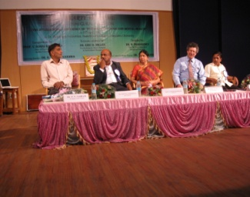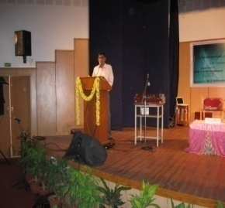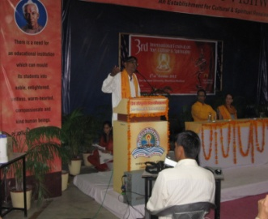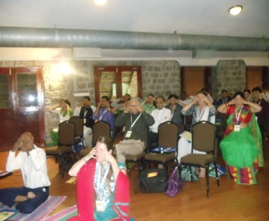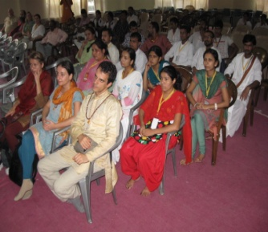
2013
0080 | LECTURE -Raga Therapy BY TV SAIRAM | Visakha Music Academy & Department of Music, Andhra University, | Aug 9, 2013 (Public Library Auditorium, Dwaraka Nagar, Visakhapatnam)
0082 | 44th Guest Lecture on ‘ Music Therapy: A Promising Medical Intervention –BY TV SAIRAM | Centre for Communication, AIIMS, Ansari Nagar, New Delhi. | Sep 26, 2013 (AIIMS, Ansari Nagar, New Delhi)
0083 | Music Therapy and its Importance in Stress Management –BY TV SAIRAM | 15th Karnataka Chapter of Anatomists’ Conference , Bengaluru | Sep 14&15, 2013 (Sapthagiri Institute of Medical Sciences & Research Centre, Bengaluru)
0084 | INTERVIEW Feast of Classical Music- An Interview of Dr Sairam by A Ramalinga Sastry | The Hindu | Date NA
0085 | Music Therapy Demo at 7th Spiritualty in Researchers Conference Venue: Gyan Sarovar, Mt Abu | Spiritual Applications Research Centre , Mt Abu, Rajasthan. | Sep 2, 2013 (Mt Abu, Rajasthan)
0086 | Workshop on Music Therapy. Music Therapy for All. A lecDem. Venue: Jain College Auditorium, JC Road, Bangalore | Manollasini Trust, Bengaluru | Sept, 15, 2013 (Jain College Auditorium, JC Road, Bangalore)
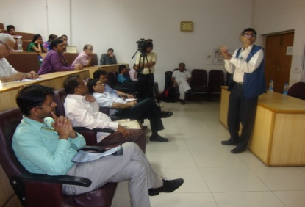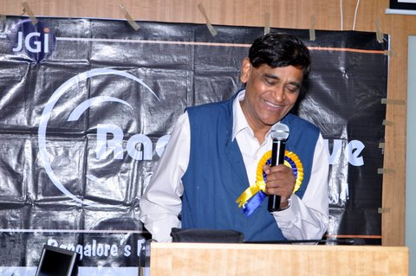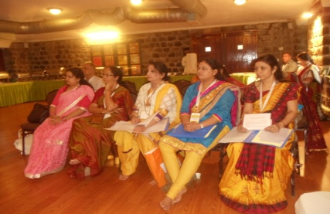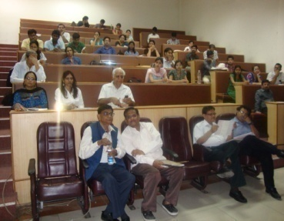
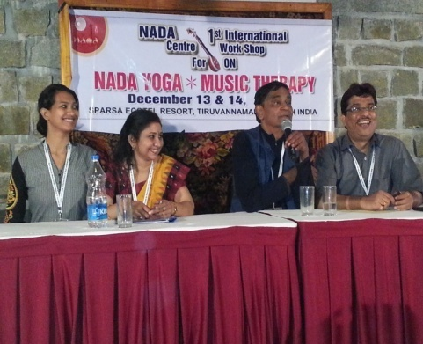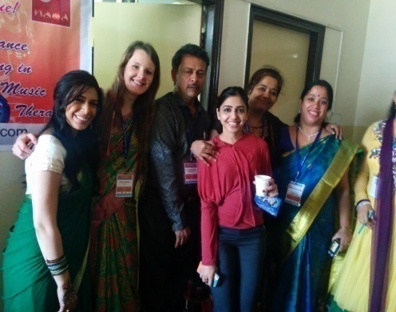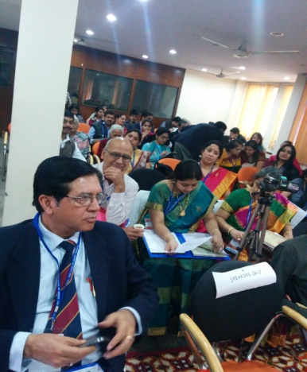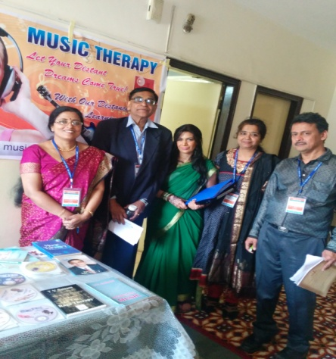
2014
0087 | Music Therapy- A Complementary Medical Intervention. – BY TV SAIRAM | Center of Community Medicine, AIIMS, New Delhi Pre-Conference Workshop of 6th World Music Therapy Conference -2014 | Mar 7, 2014 (Conference Hall, Jawaharlal Nehru Auditorium, AIIMS, New Delhi)
0088 | 6th World Music Therapy Conference -2014. |  | Mar 8&9, 2014 (Conference Room # 2, 2nd Floor, YWCA of Delhi, Ashoka Road, New Delhi)
0089 | 1st International Workshop on Nada Yoga Music Therapy |  | Dec 13&14, 2014 (Sparsa Hotel Resort, Tiruvannamalai)
2015
0090 | Carnatic & Hindustani: The Two Eyes of the Indian System of Music- BY TV SAIRAM | Souvenir of Kalavathi Foundation, Bangalore | 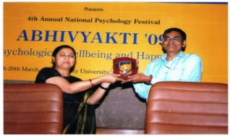
0091 | 2nd International Workshop on Nada Yoga & Music Therapy |  | Mar 29, 2015 ( Ramana Kendra, New Delhi)
0092 | 7th World Music Therapy Conference |  | Nov 28 & 29, 2015 (YWCA, New Delhi)
2016
0093 | Music Therapy: The Sacred and the Profane – BY TV SAIRAM (Book Release) |  | Second Edition, 2016. New Delhi
0094 | Devotional Music Therapy Seminar. |  | Jan 15, 2016. (Ramana Kendra, New Delhi)
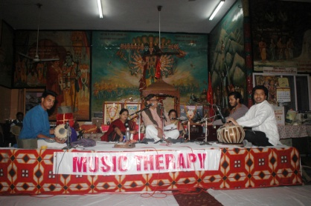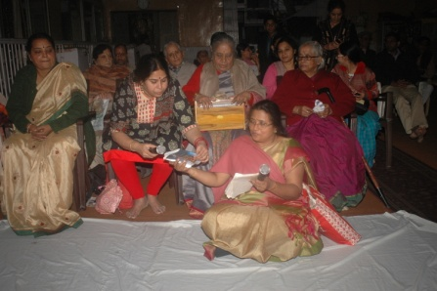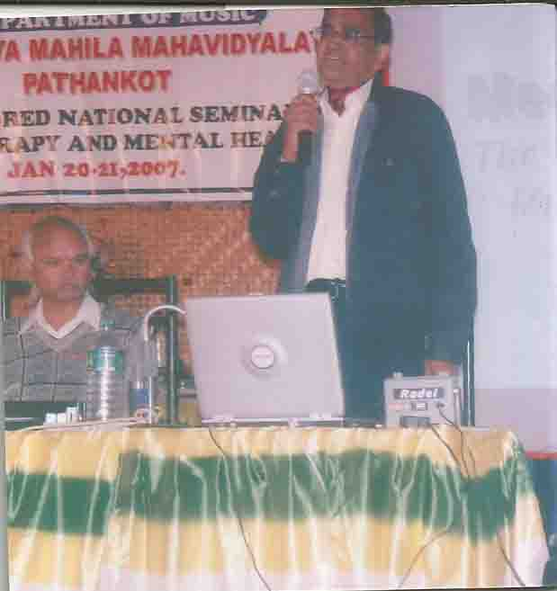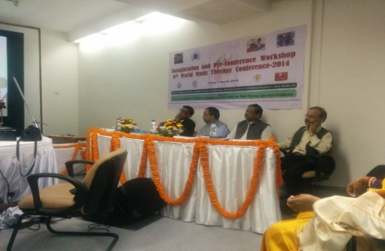
2017
0095 | Music Therapy Symposium | Organized by Mrs Rekha Malhotra | Gurgaon (Haryana) (Dates Unavailable)
2018
0096 | Nada’s Pioneering Initiative for setting up a music therapy association in india |  | May 17, 2018 Meeting for setting up of an association of Music therapy in India, Bangalore
0097 | Music Therapy Awareness Program |  | Jul 28, 2018 (Gurgon)
0098 | Music Therapy in India Lecture by TV Sairam as Representative from India (IMTA) | World Music Therapy Association. Bridging Nations and Ideas: Presidential Reports -2018 | Oct 13, 2018. Seoul, Korea
0099 | Music Therapy Digest (Editors : TV Sairam & Gayathri Sankar) (Music Therapy Digest – Extracts from Scientific and Popular Journals, | Book Release at Korea by the President Korean Music Therapy Association in the International Meeting at Seoul | Oct 13,2018. New Delhi.
0100 | What is Music? (3rd Reprint) | . | 3rd edition of the Book. New Delhi
0101 | Music Therapy in India: A Ground Report on the IMTA Movement in India | Souvenir -2018 of the First (Inaugural) Conference of Indian Music Therapy Association (IMTA) | Dec 1 & 2, 2018. Sponsored by Nada Centre for Music Therapy, Chennai (Regd) YWCA, New Delhi
0102 | First (Inaugural) Conference of IMTA, & 8th World Conference of Nada Centre for Music Therapy |  | Dec 1, & 2, 2018. (YWCA of Delhi, New Delhi, India)
2019 (Upto 15 August 2019)
0103 | Music Therapy in Clinical Settings (3rd Neuro Socio Psycho Rehab Conference) | Rayat Bahra University, Punjab) | March 1-3 ,2019 (Rayat Bahra University, Mohali, Punjab)
0104 | Music Therapy in India- Its Evolution & Current Innovation. A workshop | ,  IMTA, Arathana Hospital, Pollachi &Rotary Club Community Centre, Pollachi | May 6, 2019. (Rotary Club Community Centre, Pollachi)
0105 | Music Therapy in India- Its Evolution & Current Innovation. A workshop by NADA | IMTA & TMMTRC Kolkata | May 10, 2019 (Dr Thakur’s Hospital at Kolkata)
0106 | Emotional Music Therapy Buzz Group Study |  | Jul 28, 2019. (Centre’s Office, New Delhi)
0107 | First Medical Music Therapy Five-day Hands-on Workshop in a Hospital Setting for Music therapy Students | TMMTRC Kolkata | Aug 10-14, 2019 (Dr Thakur’s Hospital at Kolkata)
0108 | Influence of a Musical Culture in Population Traits – Western and Indian Systems A Lec-Dem. | Aristotle University of Thessaloniki, Greece | Mar 30&31, 2019 (Faculty of Fine Arts, Thessaloniki, Greece)
0109 | LECTURE -PALLIATIVE MT - Mangalore Workshop with Dr Cordula Dietrich, Dr V Subramaniam & Dr TV Sairam | IMTA & Yenepova Medical College (Deemed University) | Sept 16-18 (Yenepova Medical College, Mangalore)
0110 | MT- Gurgaon Workshop |  | Nov 17, 2019. (Gurgaon )
0111 | 2nd IMTA Conference -2019. |  | Dec 1 & 2 (Univeristy in Pune, Maharshtra)

(AND WE ARE GOING ON AND ON….!)
